Altar Server Training
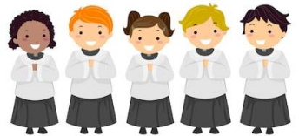
Are you being called to serve?
Infant Jesus of Prague Parish wishes to invite all Catholic children to join the Altar Server Ministry. The child must have completed his/her First Holy Communion and be in Grades 3-8. The child must be mature and responsible, and must have a heart of service. The training will be held on: Sunday, July, 10th, 2022 after the 11:00 AM Mass at the church. It is important for a parent/guardian to be present with the child during the training. This training is open to all children of the parish and school, including local public school children who fit these requirements. Please register by sending an email to Darla Draus, Ministry Coordinator, at ddraus@ijpparish.org as soon as possible. You can also bring this form in with you on training day. We are eager to welcome you all and restart this beautiful ministry.
=============================================================================================
Altar Server Training
My Child __________________________________ attends (school) ______________________________ and is in _________ grade. He/She is Catholic and has received the Sacrament of First Holy Communion. We have prayed on this decision as a family, and we feel that He / She has a heart of service, is responsible, and mature enough to join this ministry. We understand that to help our child grow in their faith we are expected to attend church regularly as well. Our preferred mass day/time is: ____________. The best contact for us is ph# _________________ and via email at: ___________________________________________Name of Parent/Guardian who will attend the training with the Child: _________________________________________________________________________________________.

